**MASTER BLASTER:**

**INTRODUCTION:**

Master Blaster is a puzzle game inspired from the idea of candy crush and other similar games which involves matching similar shapes and items into groups of three or more by swapping either vertically or horizontally, which eliminates the matched items from the play board and replaces them randomly with new shapes. Player will have a target score and after achieving the target score game will end, after which he can switch to the harder mode of game which will have higher score target and difficult to match objects.

We have given the game a little entertaining touch by making it more colorful and cheerful for the player, for this we used different kinds of emoji as objects. Also we designed different colorful and cheerful background screen for our game which includes Splash Screen (Starting Screen), Main Menu Screen, Game Screens.

**GENERAL ALGORITHM:**

Begin Game

Show Splash Screen

If any key is pressed

Move to main menu

Else

Do nothing

Enter your choice in main menu

If

choice is equals to EXIT

Close the window

Else if

choice is equal to PLAY

Move to Game Modes

If

Mode is equal to EASY

Open Easy game Screen

Else if

Mode is equal to HARD

Open Hard Game Screen

Choose the objects to blast

If choice matches

Swap objects

Count score

else

Don’t swap

If

score equals target score

You Win

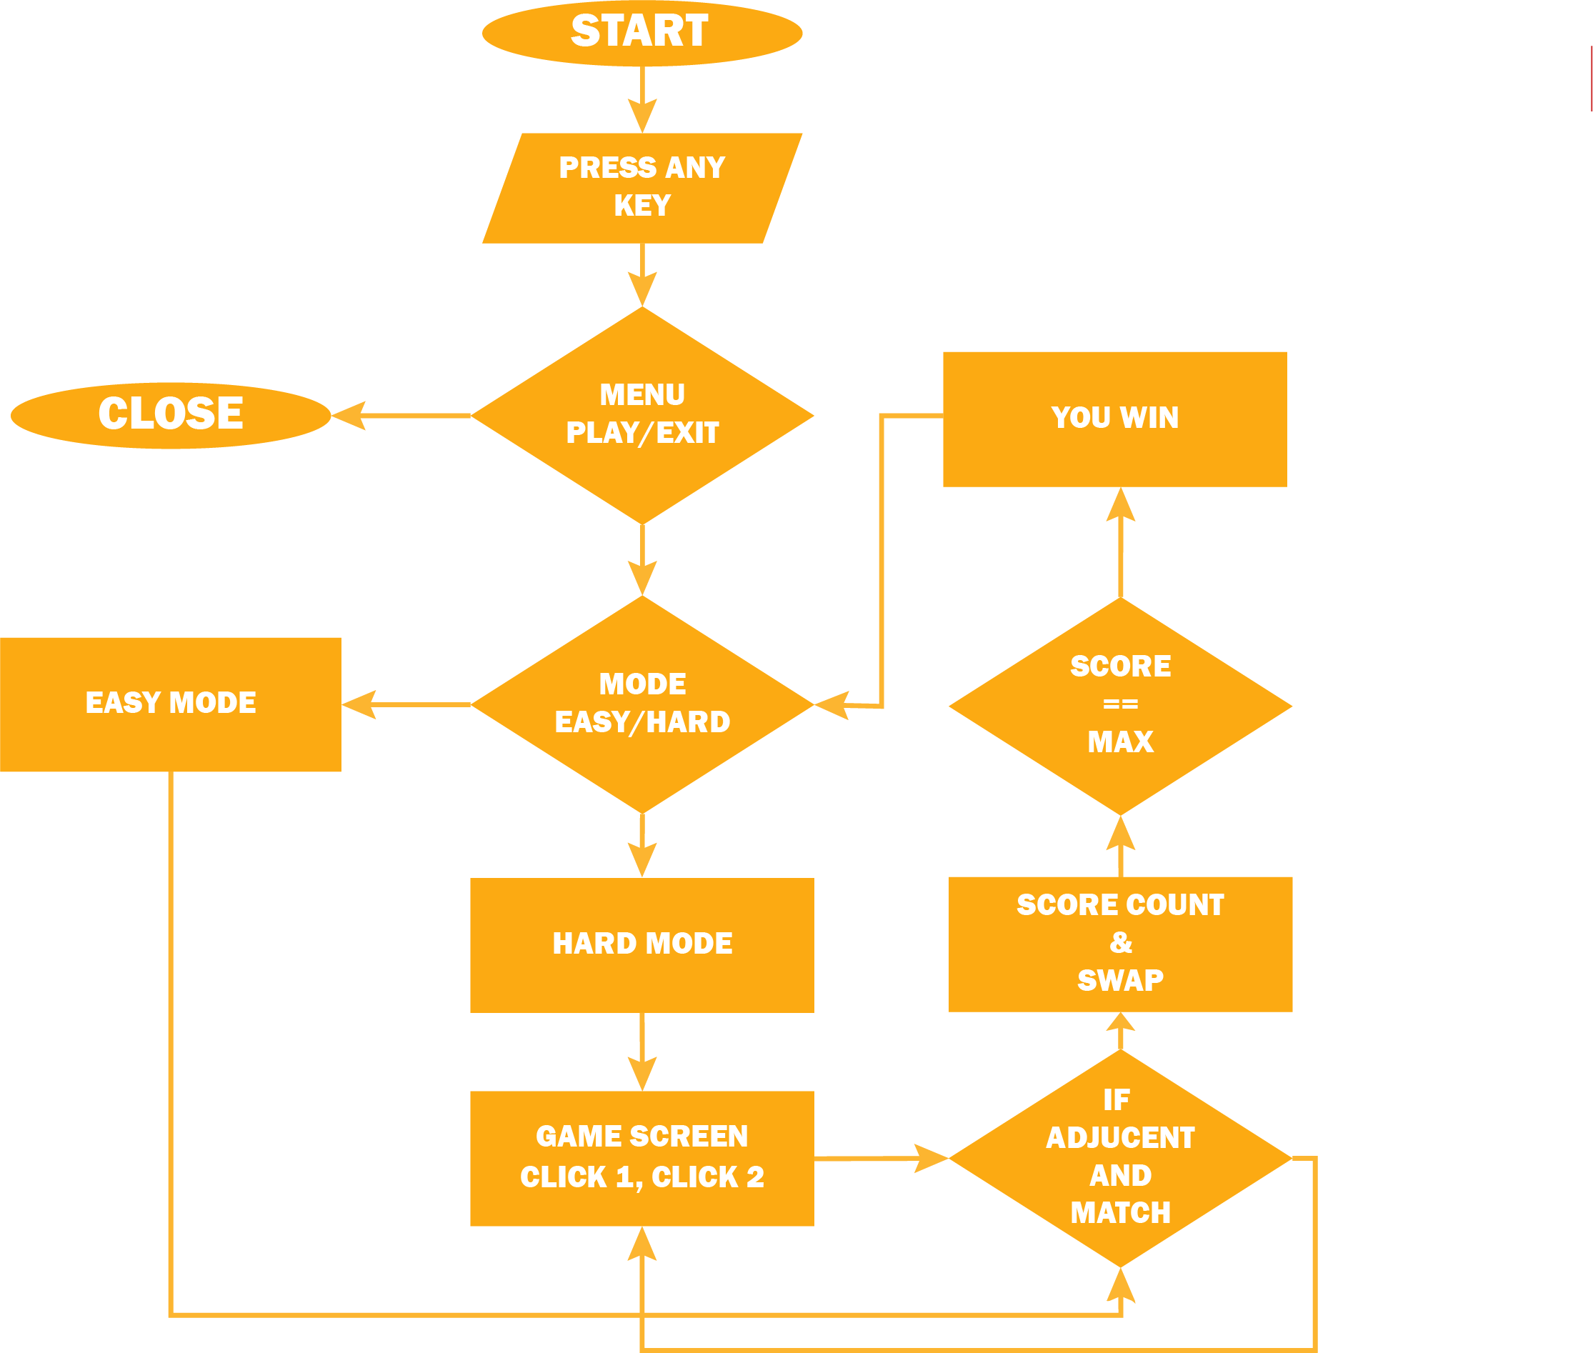**FLOWCHART:**

**GRAPHICS:**

1. **Backgrounds:**

Master blaster includes different background for main screen, menu screen and also different backgrounds for different modes of the game, e.g. Easy, Medium and Hard. All the backgrounds are designed by us. Snaps of those background are pasted here.

* **Splash Screen:**
  + 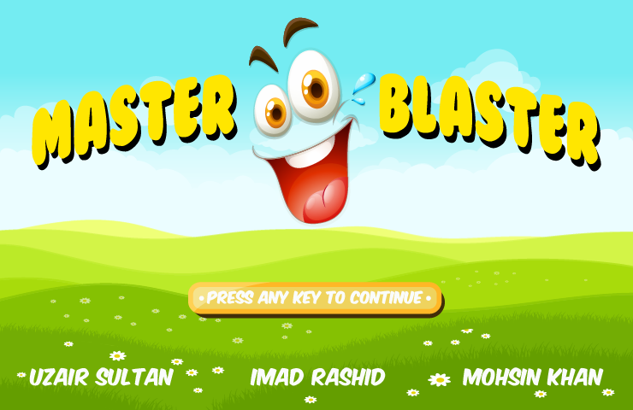Splash Screen is the starting screen of the game that includes name of the game and also names of developers. Snap Is pasted below.
* **Main Menu Screen:**

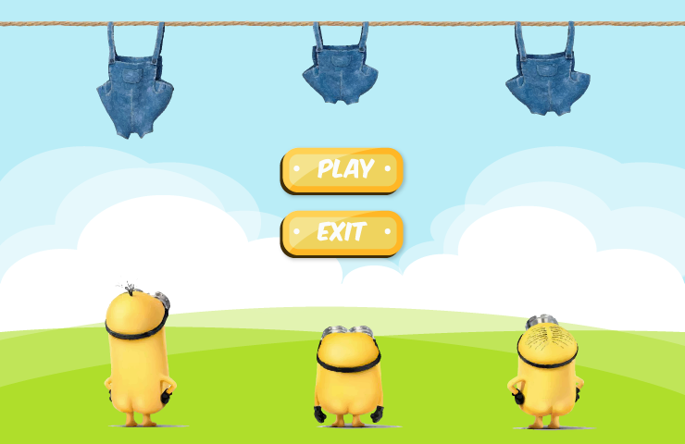

* **Game Screens:**

Master Blaster uses different background screens for different modes of game. i.e. For Easy, Medium and Hard Modes it uses different backgrounds. Snaps of the different screens designed by us are given below.

**HARD MODE:**

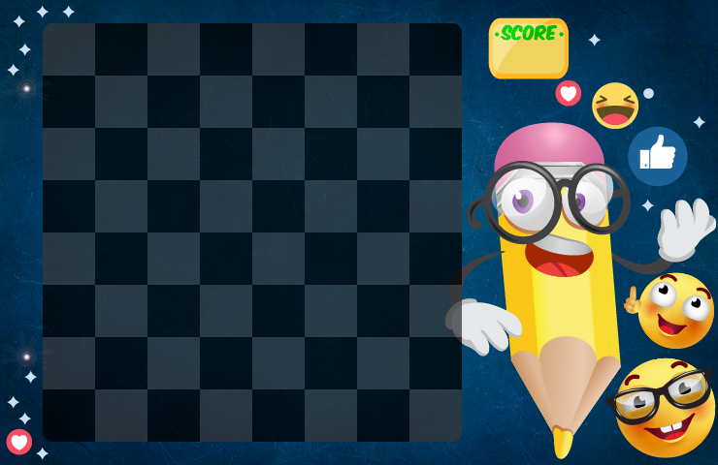

**EASY MODE:**

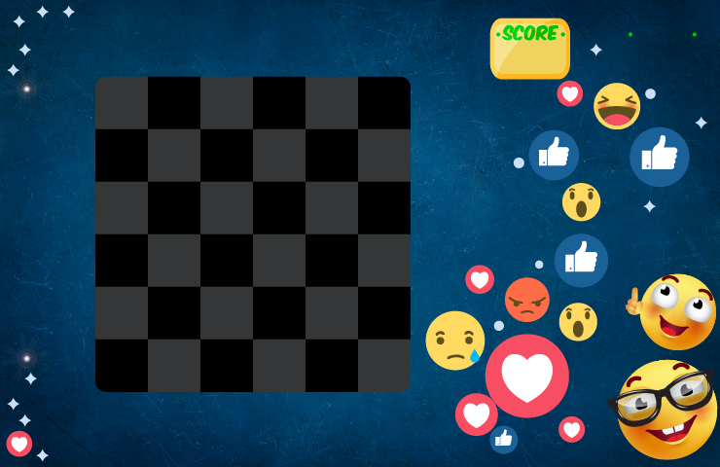

1. **Shapes:**

Master Blaster uses different emoji as its objects. All the objects are made by us and its snaps are pasted under.



**C:\Users\Uzair Sultan\Desktop\PROJECT OOP\EMOJI-01.png**

1. **Score:**

Game, Master Baster, has a target score concept, which means that the player will be given a target score which he will have to achieve in order to WIN. Different difficulty mods will have different targets to make the game harder and interesting.

**SOUNDS:**

Sounds have also been added to give the game an entertaining effect and enhance the theme of the game.

**OUTPUTS:**

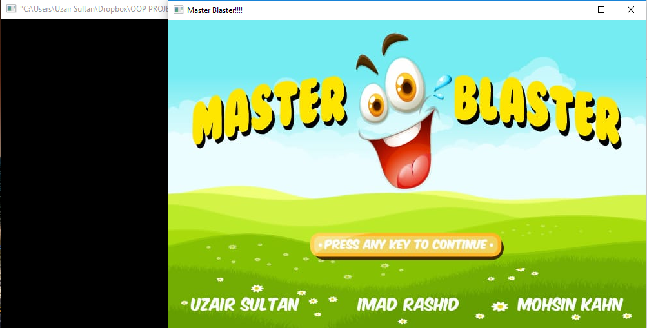

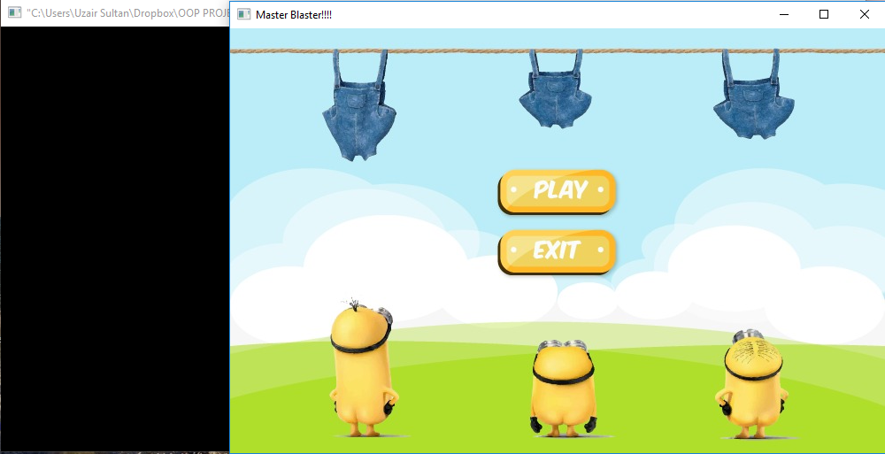

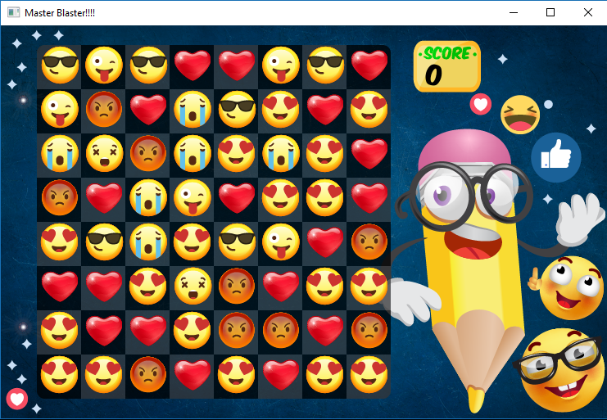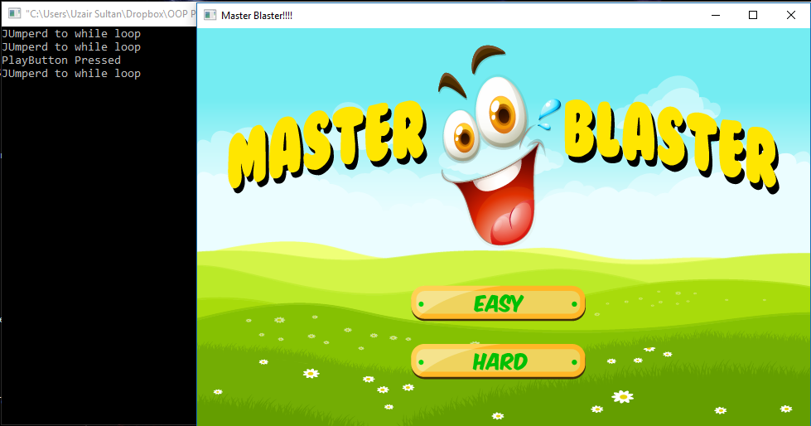

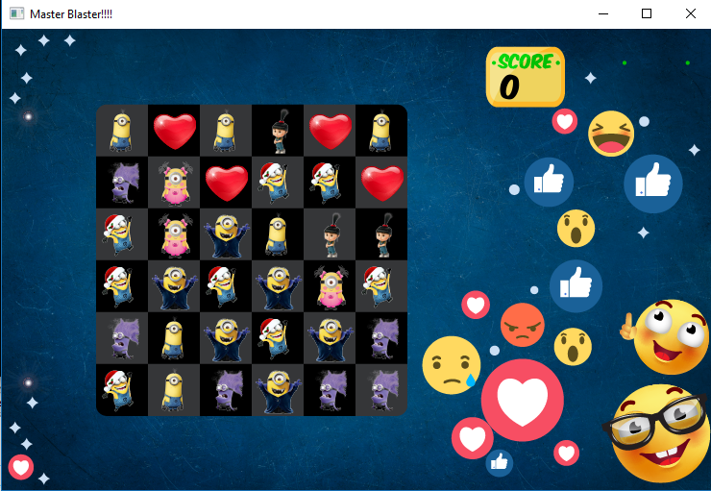

**END NOTE:**

All the target set mentioned in the proposal have been achieved successfully.